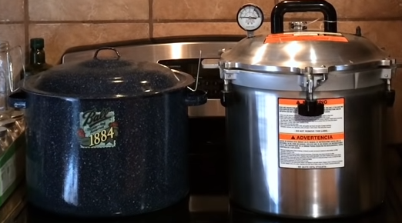

<https://imgur.com/iJZ9XRO>